**Practical-1**

**Aim: WAP to check given string is numeric or not.**

**Program:**

#include<iostream>

using namespace std;

int main()

{

char a[1000];

int i,n,x=0,y=0;

cout << "=> Enter any string : ";

cin >> a;

for(i=0;a[i]!='\0';i++)

{

if(a[i]>='0' && a[i]<='9')

{

x++;

}

else

{

y++;

}

}

if(x>0)

cout << endl << "=> This string is numeric string.";

else

cout << endl << "=> This string is not numeric string.";

return 0;

}

**Output:**

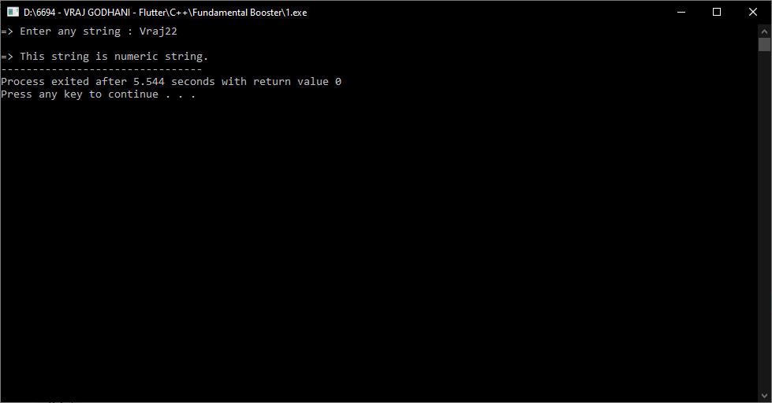

**Practical-2**

**Aim: WAP to find leap years from 2000 to 3000.**

**Program:**

#include<iostream>

using namespace std;

int main()

{

int i;

cout << "All leap years from 2000 to 3000 :- " << endl << endl;

for(i=2000;i<=3000;i++)

{

if(i%4==0)

{

cout << i << "\t";

}

}

return 0;

}

**Output:**

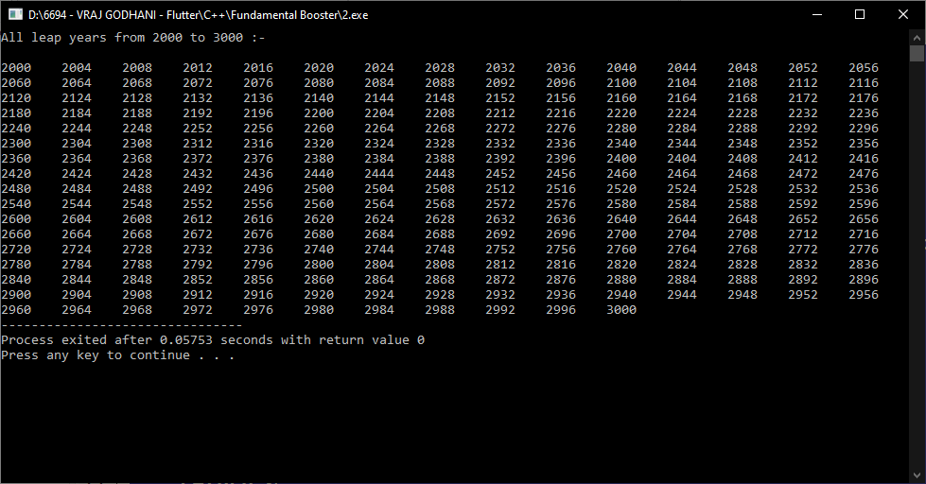

**Practical-3**

**Aim: WAP to convert given string into toggle case.**

**Program:**

#include<iostream>

using namespace std;

int main()

{

char s[1000],i;

cout << "=> Enter any string :- ";

cin >> s;

for(i=0;i<=s[i];i++)

{

if(s[i]>=97 && s[i]<=122)

{

s[i]=s[i]-32;

}

else if (s[i]>=65 && s[i]<=90)

{

s[i]=s[i]+32;

}

}

cout << endl << "=> Convert toggle case :- " << s;

return 0;

}

**Output:**

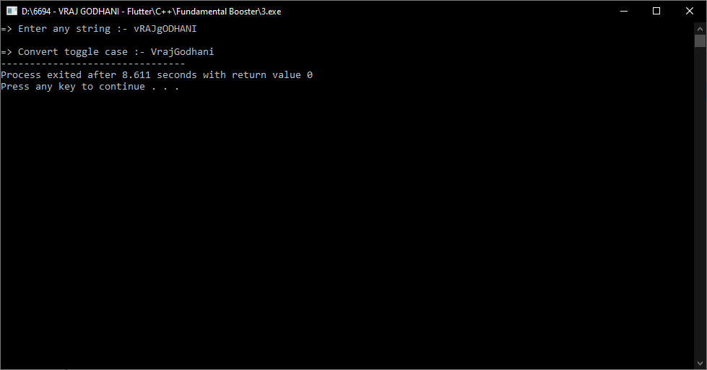

**Practical-4**

**Aim: WAP to check if a given character is vowel or consonant.**

**Program:**

#include<iostream>

using namespace std;

int main()

{

char n;

cout << "=> Enter any character :- ";

cin >> n;

if(n=='a' || n=='A' || n=='e' || n=='E' || n=='i' || n=='I' ||

n=='o' || n=='O' || n=='u' || n=='U')

{

cout << endl << "=> This character is vowel.";

}

else

{

cout << endl << "=> This character is consonant.";

}

return 0;

}

**Output:**

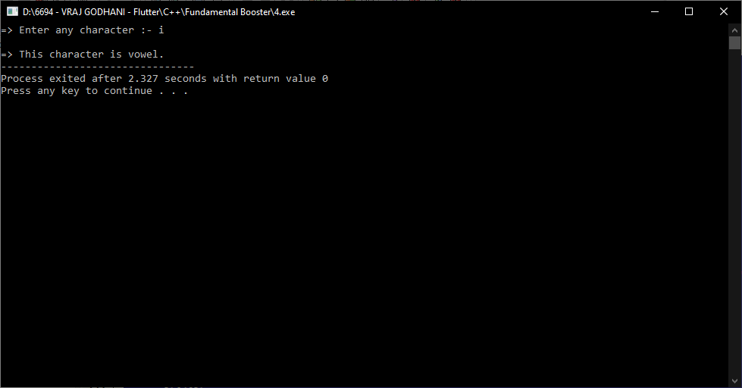

**Practical-5**

**Aim: WAP to find square root of given numbers from array elements.**

**Program:**

#include<iostream>

#include<math.h>

using namespace std;

int main()

{

int n,i;

cout << "=> Enter size of array :- ";

cin >> n;

float a[n],b[n];

cout << endl << "=> Enter array elements :- " << endl;

for(i=0;i<n;i++)

{

cout << "a[" << i << "] :- ";

cin >> a[i];

}

cout << endl << "=> Square root of array elements :- ";

for(i=0;i<n;i++)

{

b[i] = sqrt(a[i]);

cout << endl << b[i];

}

return 0;

}

**Output:**

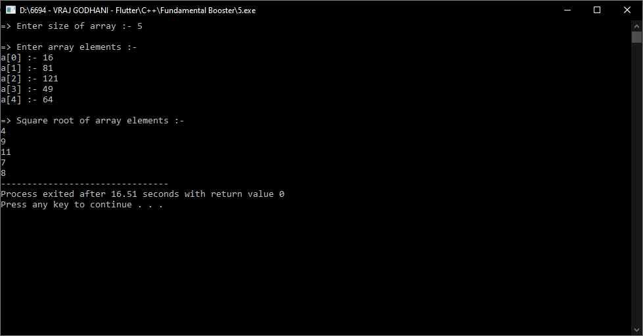

**Practical-6**

**Aim: WAP to generate cube of given 5 numbers and make an array of that generated cubes.**

**Program:**

#include<iostream>

using namespace std;

int main()

{

int a[5],b[5],i;

cout << "=> Enter array elements :- " << endl;

for(i=0;i<5;i++)

{

cout << "a[" << i << "] :- ";

cin >> a[i];

}

cout << endl << "=> Cube of array elements :- ";

for(i=0;i<5;i++)

{

b[i] = a[i]*a[i]*a[i];

cout << endl << b[i];

}

return 0;

}

**Output:**

